**Homework 4: CST Simulation**

Author: Haotian Hong

Date: 2024-06-10

ID: 2023291007

**Requirements**

1. Run two simulation of different human voxel models;

2. Investigate any factors that interest you most, either the posture of the human model, or the body size, tissue properties;

**Experiments:**

We imported the human voxel phantom with a specific pose and positioned it correctly within the coil, ensuring that the brain of the phantom is at the isocenter of the coil. The phantom's pose is as described, with crossed hands and legs. Since the phantom's feet are far from the RF coils, only a subvolume of the phantom was simulated.

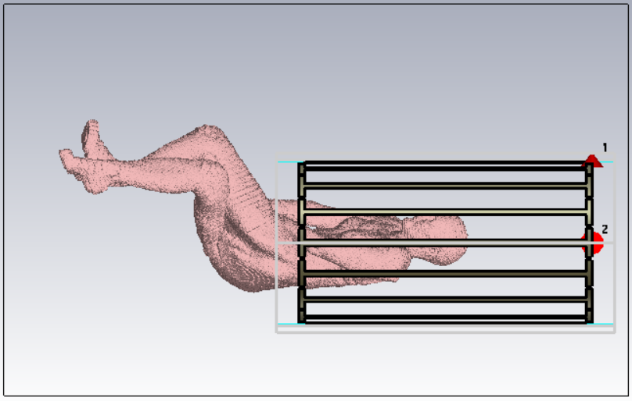 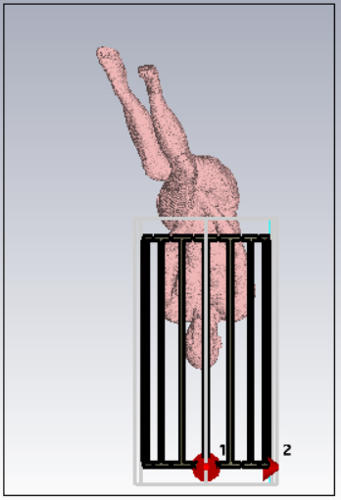

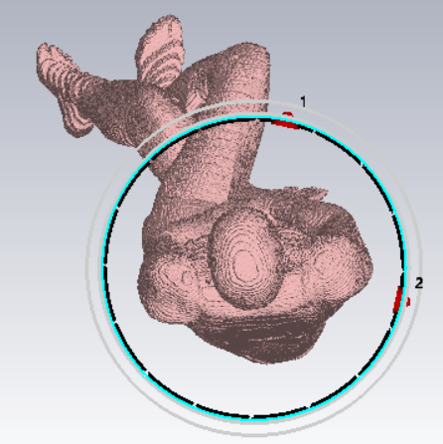 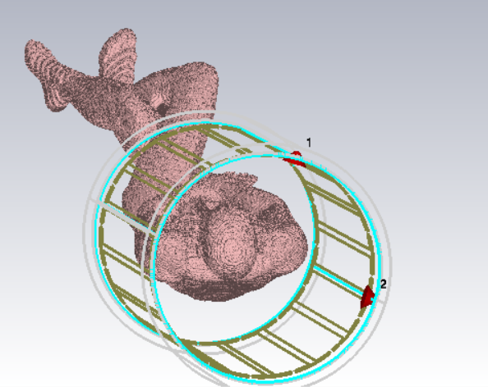

Field monitors were added to evaluate the E field, H field, power flow, current density, and thermal power loss density. Post-processing of the AC combination was performed for circular polarization visualization. The simulation results for the E field and H field are shown below, clearly illustrating the transmission of electromagnetic waves from the coil into the phantom volumns.

The E field

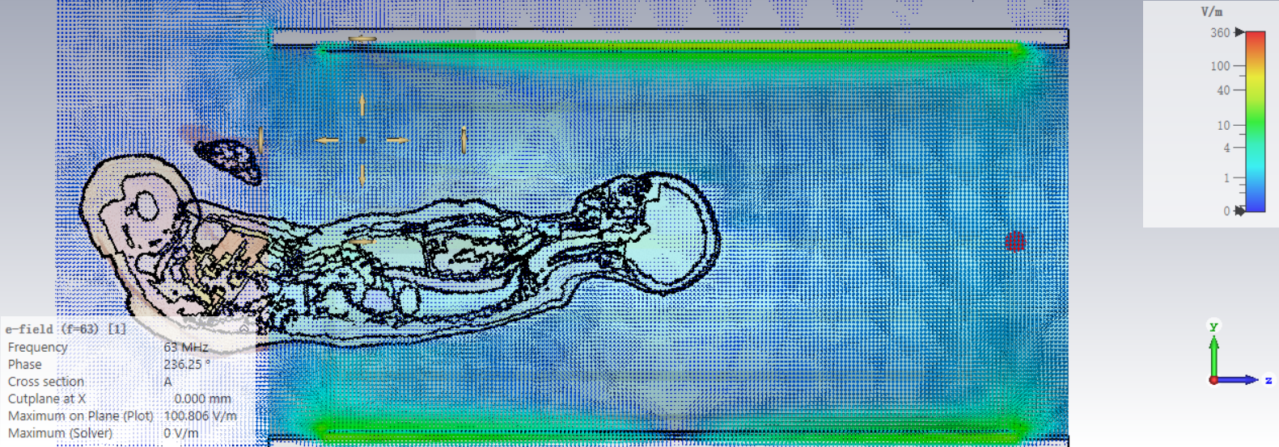

The H field

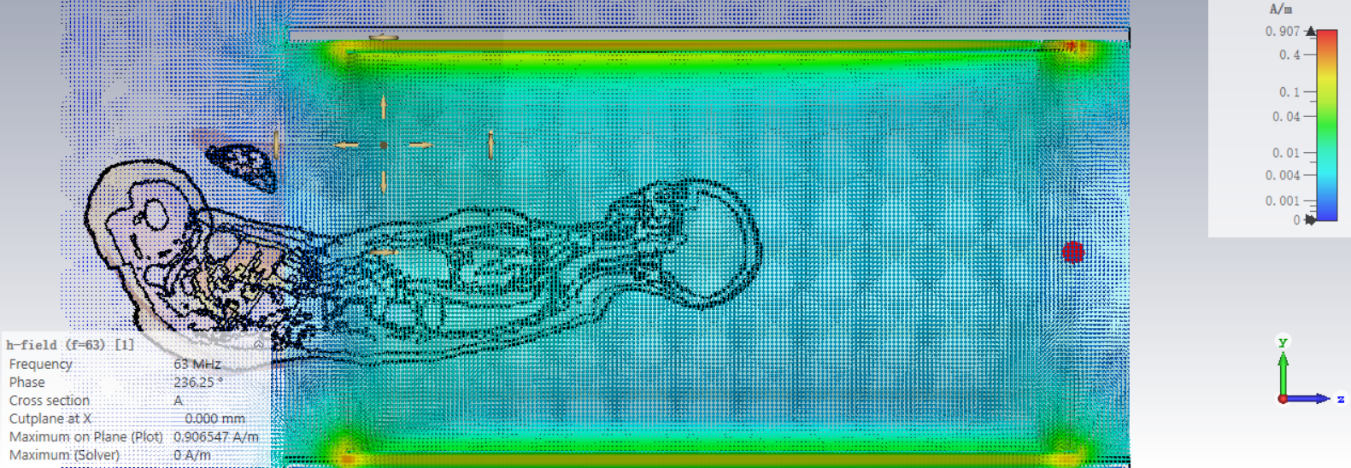

The Power Flow mainly locates along the coil surface, and partially coupled into the phantom body.

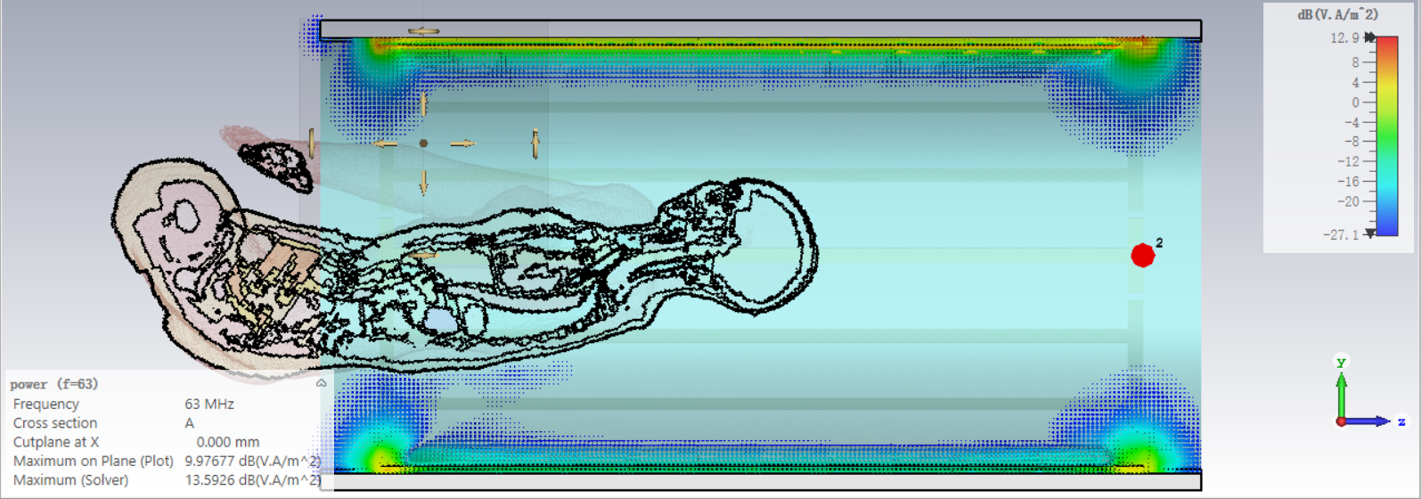

The current density is calculated within the phantom voxels. It shows a high current density along the spine and the aorta, which might lead to risk. Another interesting observation is that when the current density on the phantom surface were visualize, the neck area and the crossing arms and wrists show the highest intensity, especially along the forearm.

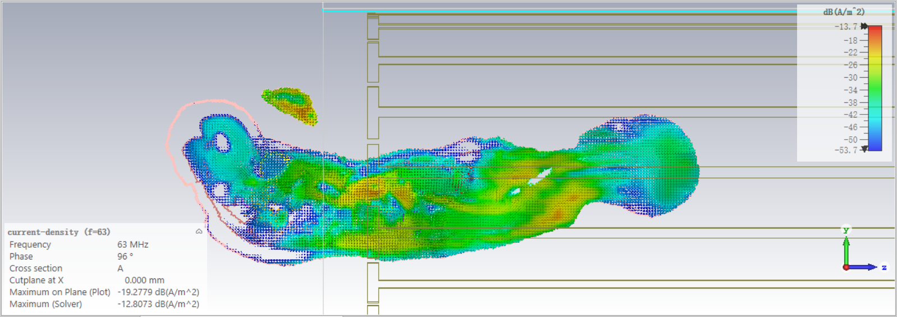

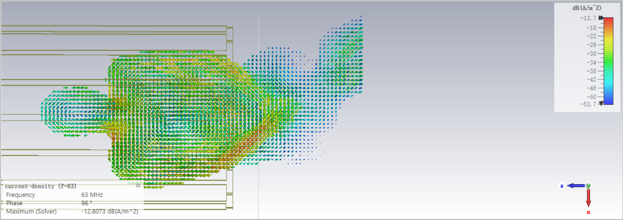

Both the power loss density and SAR represent the thermal information on the phantom body. The following three images depict the power loss density.

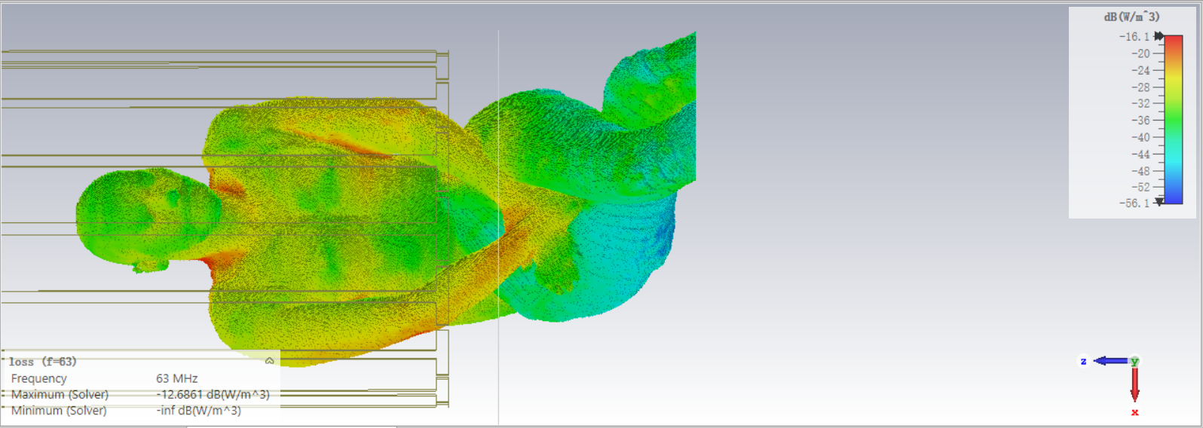

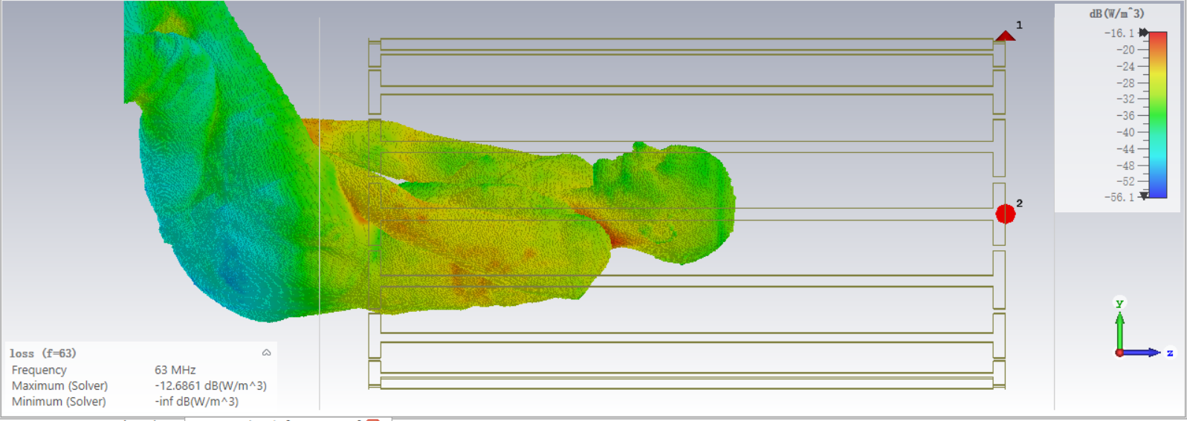

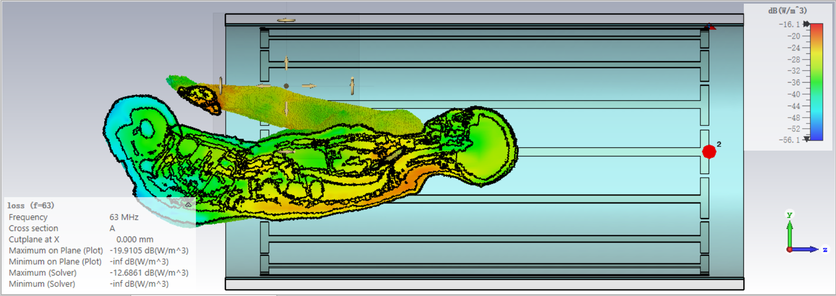

And the SAR were depicted below.

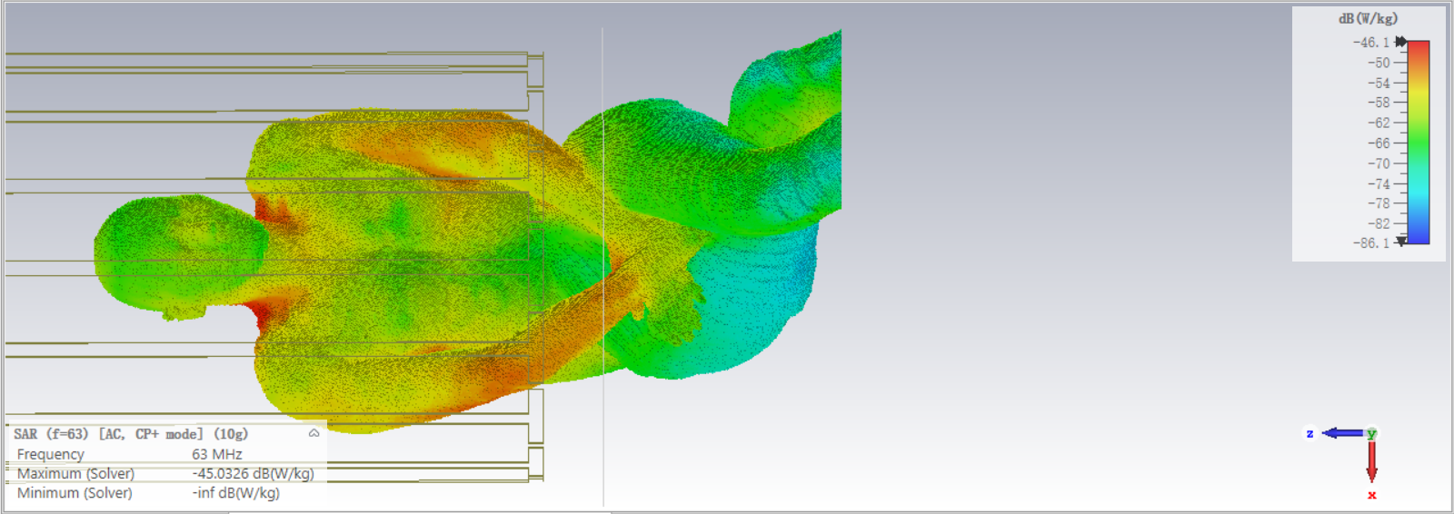

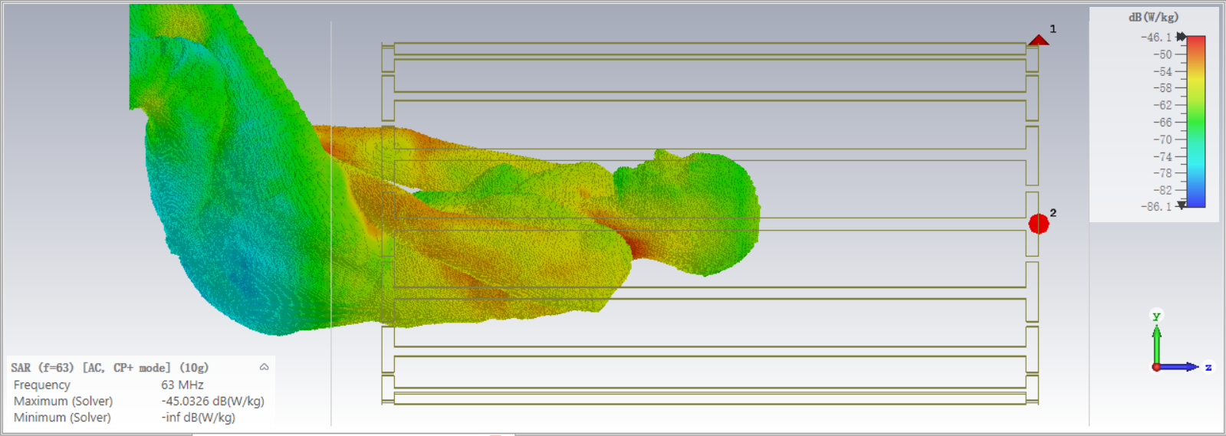

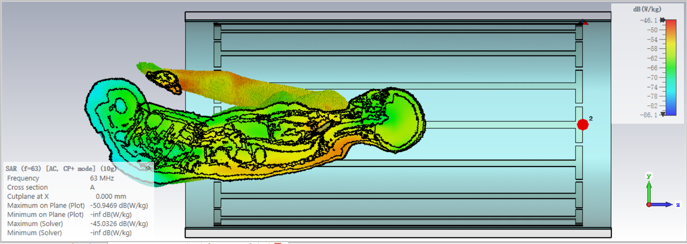

Both the SAR and power loss density plots demonstrate that the thermal hotspots are mainly located around the neck, below the armpits, and along the forearm. The current loop caused by the crossing arms increases the risk of SAR. It is also clear that the thermal issue is mainly located within the RF coil. There is no high SAR risk for the legs, even when they are crossed.

**Conclusion**

In this study, we successfully imported a human voxel phantom with a specific pose and accurately positioned it within the coil, focusing on the brain's location at the isocenter. By simulating only a subvolume of the phantom due to the distance of the feet from the RF coils, we were able to evaluate the E field, H field, power flow, current density, and thermal power loss density effectively.

The simulation results clearly illustrated the transmission of electromagnetic waves from the coil into the surrounding space. We observed that the power flow is primarily concentrated along the coil surface with partial coupling into the phantom body. The current density analysis revealed high concentrations along the spine and aorta, indicating potential risk areas. Additionally, significant current density was noted in the neck and forearms, particularly in regions with crossed arms and wrists.

Thermal analysis through power loss density and SAR mapping identified hotspots mainly around the neck, below the armpits, and along the forearms. The crossing of the arms appears to create a current loop, increasing the SAR risk. However, no significant SAR risk was detected in the legs, even when crossed.